

FRANKFURT 2010
Frontlist

GALAADE ÉDITIONS • 108 RUE DAMRÉMONT 75018 PARIS-F • +33 1 42 23 56 02
PRESIDENT AND PUBLISHER: EMMANUELLE COLLAS emmanuelle@galaade.com

Foreign Rights, Buyer: Cécile Magné • cecile@galaade.com
Foreign Rights, Seller: Romaric Vinet-Kammerer • romaric@galaade.com
Representative: Pierre Astier & associés • pierre@pierreastier.com

FRONTLIST / FALL 2010
WORLD RIGHTS / UPMARKET COMERCIAL FICTION

She will change your life.
Charming and deeply wonderful

HUgo lamarck
MYRTILLE
A NOVEL

That's the way Myrtille is.  One loves her, other adore her. She rarely leaves unmoved. On the contrary, she will make you fall in love for her.  Thirty years-old, serene Myrtille is a fruit that breathes love whatever the season is.  Myrtille knows it: happiness is built on moving sand and is each day threatened by the tide. From Monceau Park to the heart of Montmartre, Myrtille can't help but spend her days inventing a universe for dream and imaginary.  Myrtille: it is a strange bird-masked character that appears where one doesn't expect it; it is a white pages book, as white as nights are. It is Angelo in her heart, but not in her bed.  Myrtille: a wonderful love story, a poetic fable that sparkles, a simple and beautiful invitation to pleasure.  Myrtille has been selected as 2010's Summer Novel by Parship, Europe's leasing online dating service.  finalist, orange prize, 2010  “Paris I love you!” – tgv magazine  “Tender and full of charm, Myrtille is a wonderful novel” – zeitung vum lëtzebuerger vollek (luxembourg)  "Between Prevert and Amélie Poulain, a pure pleasure!" – vaux livres bookstore  “Sweet, funny and poetic: Myrtille is a real success!” – les jardins d'hélène (reader's blog)  “Almost perfect, Myrtille is a delicious surprise” – sophielit (reader's blog)  - love story / Paris / fate / happiness  - A tender and full-of-wonders novel on love and fate  in contemporary Paris  - an unforgettable journey in today's Paris  RIGHTS AVAILABLE  160 P. APRIL 2010 | 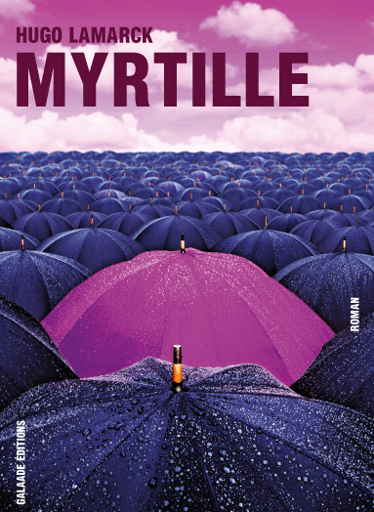  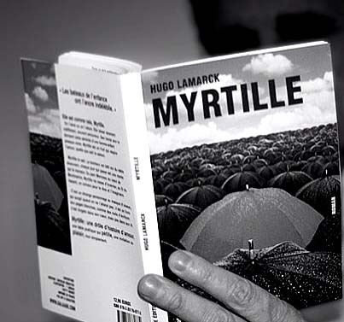  The author  Hugo Lamarck is a lyric writer and writes plays for the theatre. Myrtille is his first novel.
FRONTLIST / FALL 2010
WORLD RIGHTS / LITERARY FICTION

One tumultuous sleepless night, or,
the ravishing of Léonce

MANUEL PIOLAT SOLEYMAT
TROIS SURPRISES À BORD DU BAHNHOF ZOO  (THREE SURPRISES ON BOARD OF THE BAHNHOF ZOO)  A NOVEL  One won't know anything precise, but the gestures are tumultuous. An established woman, Léonce abandons her home. While she flees away to meet and dance with other men, Michel accuses and exhibits the faults of this woman he hates and worships for her sensuality.  Choral and demanding, this short fiction stages the words and silences of one's life.  "Léonce Janssen belongs to a lineage of women of excess, one think about Lol V. Stein, with the figures of dance and sleepless nights, or of these erotic shots of Ava Gardner with the boys in The Night of the Iguana." – diane scott  "A sophisticated and fascinating piece of writing." – michel bataillon  - the words one tells and the words one holds  - women / infidelity  - sensuality and desire  - transgression | 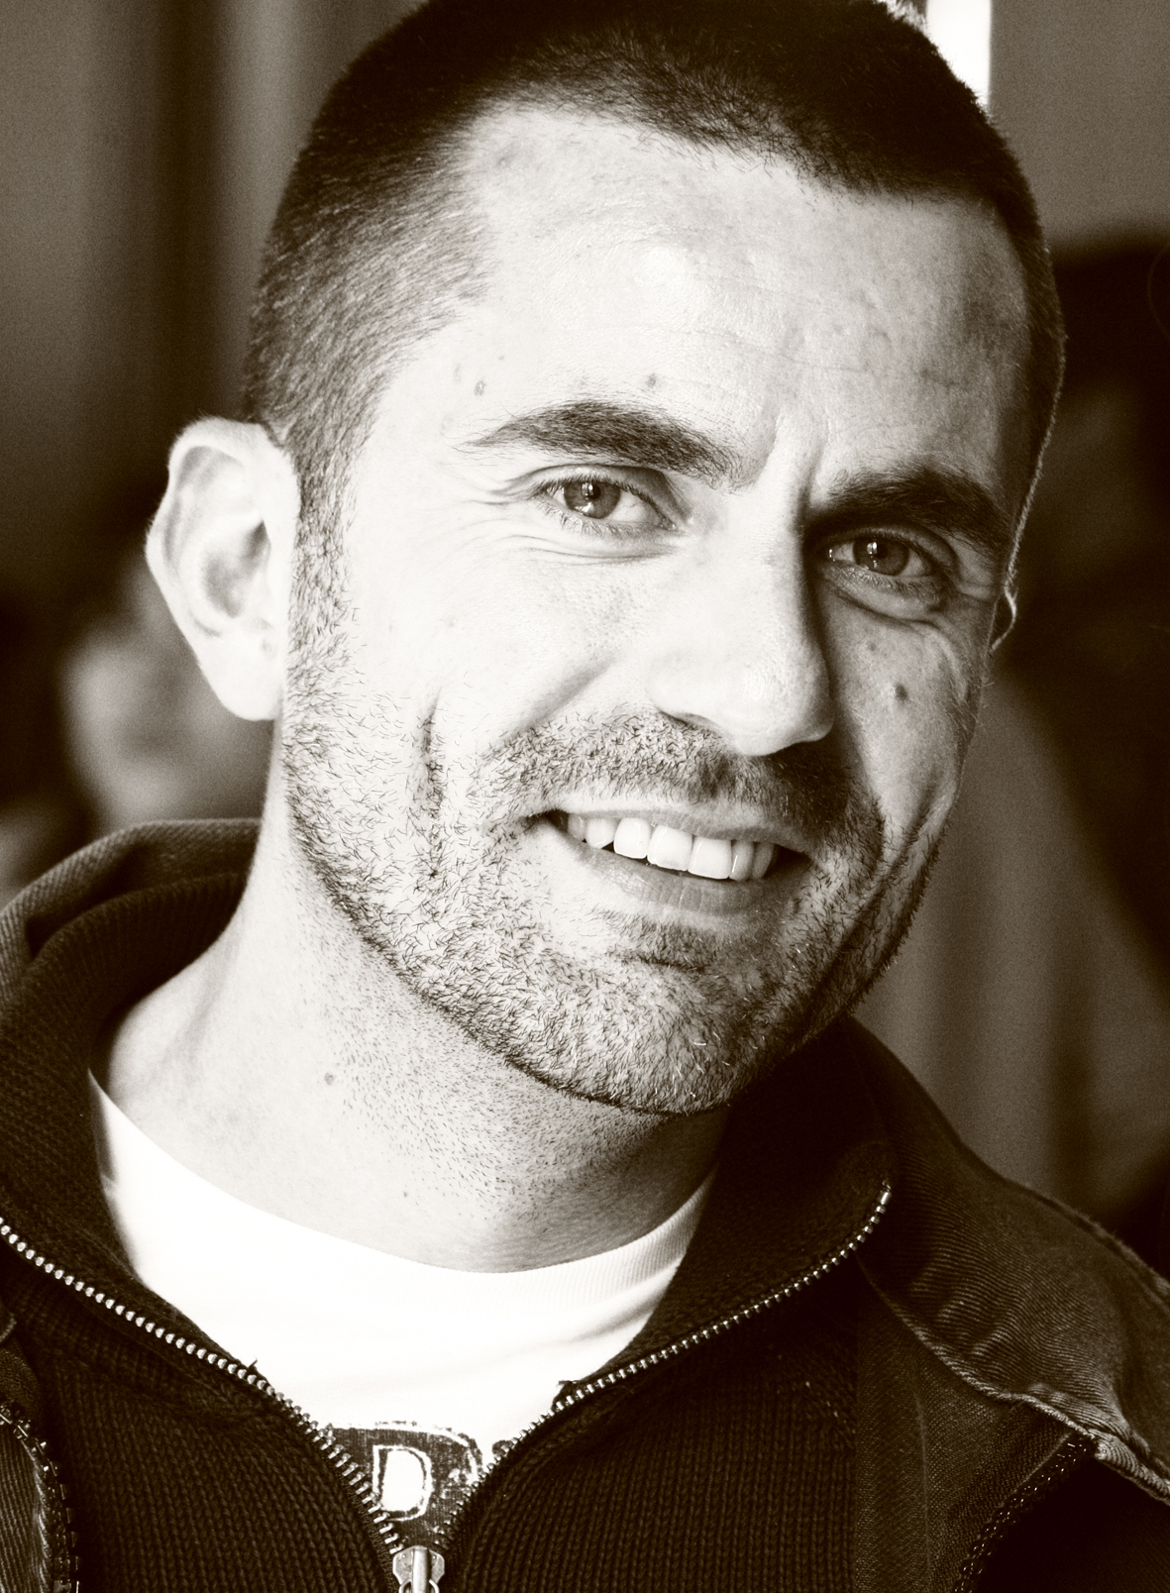  The author  A drama critic and radio host, Manuel Piolat Soleymat is the author of several theatre plays.

Rights available
Reading copy available
128 P. TO BE PUBLISHED IN february 2011

FRONTLIST / FALL 2010
WORLD RIGHTS / LITERARY FICTION

Brilliant and singular : a literary tour de force

Sylvie taussig
MUETTE  (WORKING TITLE)  (MUTE)  A NOVEL  Meet Diane, a thirty-ish woman leading a dull life with Franck, her husband who doesn’t understand her and that Diane sometimes fantasizes with someone else’s features, and the haunting memory of her friend Anne, dead for twenty years, and of their dreams.  For the past fifteen years, Diane has been making her living reading biographies for publishing houses. Her head can no longer contain the stories of people of all ages, coming from everywhere and from every background. She has seen it all, lived everything, vicariously. Confirmed monger, she has appropriated these stories and tell them to her friends as if it belonged to her.  Until the day she is struck down by lightning, and loses her voice…  - a tale of modern society and its cruelty  - a social satire in the lineage of Houellebecq  - Sylvie Taussig: a new voice to follow  Rights available  Reading copy available  320 P. TO BE PUBLISHED IN JANUARY 2011  FORTHCOMING: | 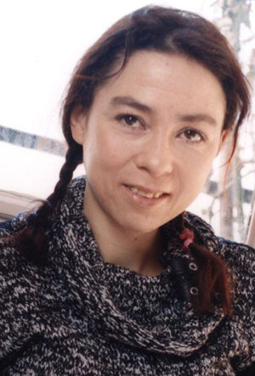  The author  Born in 1969 in Paris, Sylvie Taussig is the author of 10 books including the novel Prison (2000) and Patron titan (Galaade, 2006). Muette is her third novel. The translator of Hannah Arendt, Tony Judt and Martin Walser, Sylvie Taussig is also a scholar affiliated with the National Center for Scientific Research.
DANS LES PLIS SINUEUX DES GRANDES CAPITALES
(WITHIN THE SINUOUS FOLDS)
A NOVEL

It’s a black blind wall in a street of Paris. Once, ten or fifteen years ago, it was part of Claude-Hélène’s failed project of urban micro-interventionism. But why does it reappear now? And what does it mean, anyway? Astutely assembling all the pieces like a mosaic, Sylvie Taussig invents a tale about our cities and what they say about their inhabitants.

Rights available
Reading copy soon available – TO BE published in 2013

also available:  PATRON TITAN  (THE SUPERHUMAN BOSS)  A NOVEL  Eighteen days in the life of Hugues Chavier, head of an international company. An inventive and poignant novel.  RIGHTS AVAILABLE  352 P. FEBRUARY 2006 | 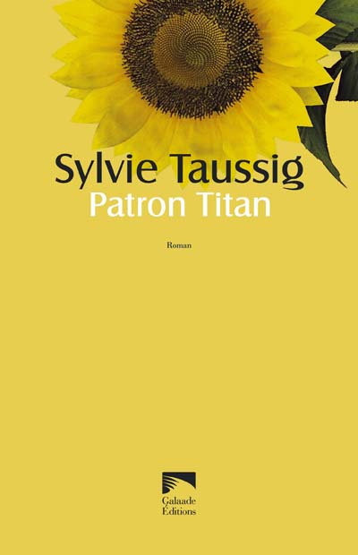

FRONTLIST / FALL 2010
WORLD RIGHTS / LITERARY FICTION

When that obscure object of desire
meets the unbearable lightness of being

Frédéric Teillard
LE TRIO INACHEVÉ  (WORKING TITLE)  (THE UNFINISHED TRIO)  A NOVEL  It is New Year's eve in Paris. Gilles, is alone at home while Alix, his wife, supposedly visiting her parents in the South-East, is with her lover Nino in Normandy.  A narration of intimacy, personal quest and doubts, a chronic of time as it passes, Le Trio inachevé tells about one's difficulty to write and adultery, through thethe days as they go by.  Will the complex arrangement of these character's life hold for the time of the holidays?  In this splendid and sensual novel, the question of love and its volatility intertwine with a reflection on the craft of writing, and their intimate bond.  "A humanity that deeply touches and distresses." – le monde  "Wonderful pages in which the reader will find himself." – le nouvel observateur  - couple / infidelity / writing / inspiration  - deam and reality  - the question of love and its volatility  - a touching and beautiful style  Rights available  Reading copy available  256 P. TO BE PUBLISHED IN SEPTEMBER 2011 | 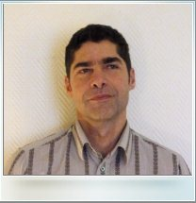  The author  Born in Belgium in 1956, Frédéric Teillard grew up in Belgium, France and Germany.  A psychoanalyst and professor of French, he lives in Paris. Le Trio inachevé is his third novel.

FRONTLIST / FALL 2010
WORLD RIGHTS / NON FICTION

To free the imaginaries

edouard glissant AND patrick Chamoiseau
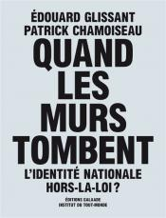

the call  “We request that all the human forces, from Africa, Asia, the Americas, Europe that all the stateless people, all the ‘Republicans’ – all the tenants of the rights of man, that all the artists, all authority founded by citizens of good will raise up by all means possible, a protest against this wall ministry which attempts to house us badly, to get us used to the unsupportable.”  With Quand les murs tombent, Patrick Chamoiseau and Edouard Glissant open a renovated reflection on the notion of identity and warn against “walls” which “are threatening the relation to the Other.  Hot-wired with L’Intraitable Beauté du monde, the best selling open letter to the first African-American to take on the White House, these two crucial yet literary texts form a diptych that actualizes the form of the pamphlet to address an all-embracing call to the world and to renovate contemporary migratorial politics.  At the crossroads of poetics and politics, they met both critical acclaim and commercial success and have become a long seller in their native country.  - essay / politics / migrations / europe / united states  - number 1 best-seller – january 2009  RIGHTS AVAILABLE (English & Spanish translation available)  SOLD:  Italy (Nottetempo-Bompiani)  96 P. JANUARY 2009  FORTHCOMING:  CARTES DU MONDE  Manuscript available in the end of 2010  250 P. TO BE PUBLISHED IN 2011 | the authors    Edouard Glissant is a pre-eminent writer, poet and a major theorist in post-colonial thought. He received the Prix Renaudot in 1958 and was short-listed for the Nobel Prize in 1992 and 2010.    Patrick Chamoiseau was awarded the Prix Goncourt in 1992 for his novel Texaco.
also available:
Manifeste pour les « produits » De haute nécessité  (MANIFESTO ON ESSENTIALS)  A political viewpoint for the social revolt that is shaking the French overseas départements and their past as a colony.  ESSAY / POLITICS / ECONOMICS / POSCOLONIAL  RIGHTS AVAILABLE  SOLD:  Japon (Iwanami Shoten)  16 P. MARCH 2009 | 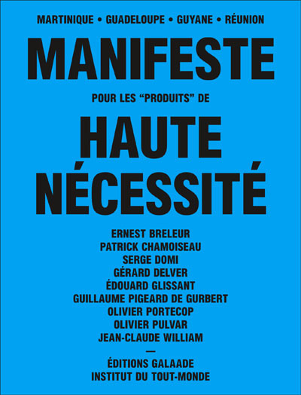
FRONTLIST / FALL 2010
WORLD RIGHTS / NARRATIVE NONFICTION

The reinvention of romance

LAURE KAtSAROS
UN NOUVEAU MONDE AMOUREUX
célibataires et prostituées
au xix^{e} siècle

(A LOVER'S NEW WORLD
BACHELORS AND PROSTITUTES IN THE 19th CENTURY)

ESSAY

Her name was Fantine in Les Misérables, Fleur-de-Marie in Eugène Sue’s Les Mystères de Paris. For Huysmans, she was Marthe; for Zola, simply, “Nana.” In art, she was called “this Olympia woman from the Rue Mouffetard” Sarah Bernhardt was one of them too. Whether real or fictional, they all play their part on the boulevards of Paris, the greatest stage of all. At night, these dazzling idols, venal creatures, and whores-with-hearts-of-gold deck themselves out in garish colors, hoping to catch the eye of passing men. The clandestine prostitute denounced by the police as insoumise dances and spins in her scarlet stockings and high-heeled ankle-boots, her embroidered petticoats clenched in her fists. As she marches up and down the asphalt sidewalks, her eyes flash from beneath the shadow of her hat like a portrait in its frame. In the cafés, dancehalls, theaters, and racetracks of Paris, the visibility of these women infuriates both police prefects and family men; but it delights the bachelors, dandies, and flâneurs who also come alive at night under the gas-lights. Their names are Gérard de Nerval, Gustave Flaubert, the Goncourt brothers, Stendhal, or Joris-Karl Huysmans.  In those days, bohemian artists and women of ill repute lived in close contact, and often shared the same dismal fate. But their unholy union struck terror at the heart of the nineteenth-century bourgeois. In her exploration of modernity, marginality, and radically changing gender roles, Laure Katsaros brings the extraordinary world of dandies, grisettes, and brothel girls back to life, along with the fear and fascination inspired by this new world of love.  - history / literature / arts  - Paris  - a refreshing approach to one of the most  famous couple of 19th century art  RIGHTS AVAILABLE  288 P. TO BE PUBLISHED IN OCTOBER 2010 | 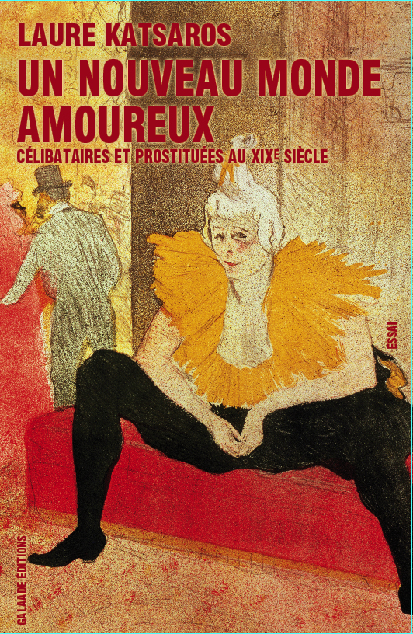  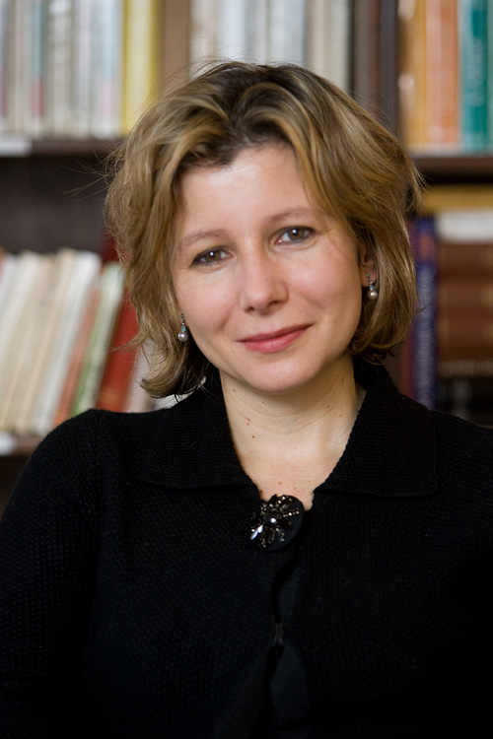  The author  Assistant Professor of French at Amherst College, Laure Katsaros is a graduate of École Normale Supérieure in Paris (rue d’Ulm). She holds a Ph.D. degree in comparative literature from Yale University and a doctorate in American studies from Université Paris VII.

FRONTLIST / FALL 2010
WORLD RIGHTS / NON FICTION / "AUTEUR DE VUE" SERIES

"AUTEUR DE VUE"
Firmly rooted in today’s debates, this audacious new series features
acute, brilliant and literary essays by important contemporary figures

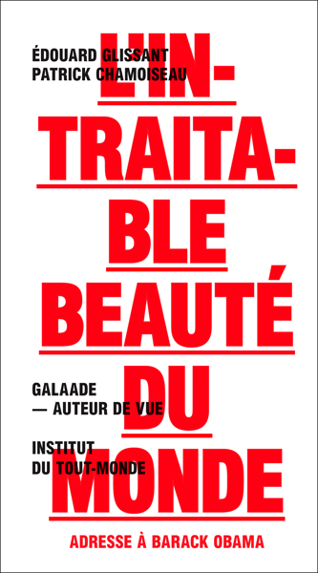  edouard glissant  patrick Chamoiseau  L’INTRAITABLE BEAUTÉ DU MONDE  (THE UNCOMPROMISING  BEAUTY OF THE WORLD)  NUMBER 1 BEST-SELLER  64 P. JANUARY 2009 | 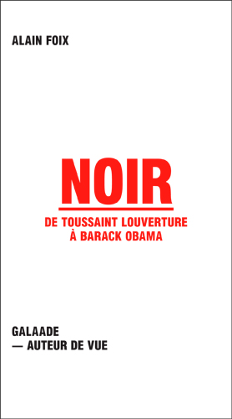  ALAIN FOIX  NOIR  DE TOUSSAINT LOUVERTURE À BARACK OBAMA  (BLACK. FROM TOUSSAINT LOUVERTURE  TO BARACK OBAMA)  96 P. APRIL 2009
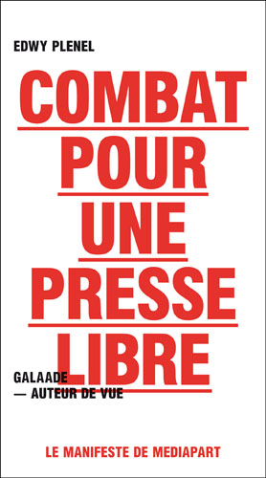  EDWY PLENEL  COMBAT POUR UNE PRESSE LIBRE  (TO FREE THE PRESS)  96 P. MAY 2009 | 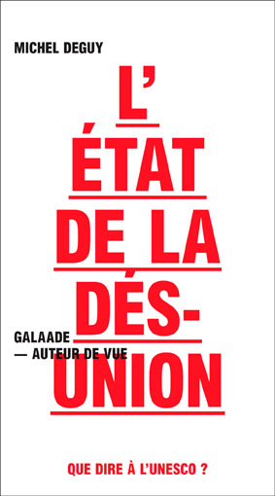  MICHEL DEGUY  L’état de la désunion  QUE DIRE À L’UNESCO ?  (CULTURE AND GLOBALIZATION)  64 P. MARCH 2010

FRONTLIST / FALL 2010
WORLD RIGHTS / NON FICTION / "AUTEUR DE VUE" SERIES

Visionary and illuminating
An urgent reflection on the emancipatory
power of the culture

MICHEL DEGUY
L’état de la désunion
QUE DIRE À L’UNESCO ?
(CULTURE AND GLOBALIZATION)

ESSAY

L’État de la désunion is Michel Deguy’s urgent reflection on the emancipatory power of culture in early 21st century.  As the United Nations Educational, Scientific and Cultural Organization is about to turn 65, Michel Deguy lists priorities and directions for a reinvention of its upcoming missions. Arguing that such a renovation won’t be possible without a radical approach to the question of cultural diversity, the poet pays tribute to the founders’ initial project only to map 21st century emergencies.  Visionary and illuminating, this brief text is a revelatory journey to the heart of contemporary realpolitics and a call for the rebirth of radical thinking.  “Stimulating” – mouvement  - politics / global culture / diversity / heritage  - visionary and illuminating  - a call for the rebirth of radical thinking  RIGHTS AVAILABLE  64 P. MARCH 2010 | 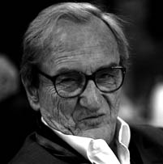  The author  A poet, philosopher and professor at the Université de Paris VIII, Michel Deguy is one of the most notorious poets of contemporary French poetry. He received the Grand Prix national de la poésie in 1998 and the Grand prix de poésie de l’Académie française in 2004.
FRONTLIST / FALL 2010
WORLD RIGHTS / NON FICTION / "AUTEUR DE VUE" SERIES

What does it mean to inhabit
a skin color?

ALAIN FOIX
NOIR DE TOUSSAINT LOUVERTURE À BARACK OBAMA
(BLACK. FROM TOUSSAINT LOUVERTURE TO BARACK OBAMA)

ESSAY

In Noir de Toussaint Louverture à Barack Obama, Alain Foix explores timely issues of race, class, identity, colonial history, and education.  Paying homage to historical and mythical figures such as Toussaint Louverture, Martin Luther King, Nelson Mandela or Othello, Alain Foix reminds us which great struggles have shaped today’s victories and outlines what remains to be done.  Genuinely political, this short essay offers an insightful deconstruction both of the language and its representations, showing that a cultural, social and economical liberation will necessarily have to consider the transmission of historical knowledge.  “Alain Foix has the temerity to do several things with varying degrees of brilliance. Born in Guadeloupe but moved to Paris with his mother when he was eight, he has made his name as an author, playwright, theatre and documentary director, professor of philosophy and, as if that were not enough, sometime choreographer.” – the observer  “Brilliant, unclassifiable and iconoclastic.” – evene.fr  - current affairs / history / identity / language  - a deconstruction of the language and its representation  RIGHTS AVAILABLE  96 P. APRIL 2009 | 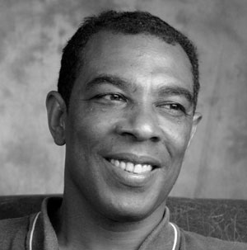  The author  Philosopher and playwright, recipient of the first prize at the Caribbean competition of Francophone theatre for his play Vénus et Adam, subsequently scheduled at the Comédie Française. A regular contributor to the national daily Libération, Alain Foix also wrote the fictions Peintre peint sur papier peint (Galaade, 2005) and Vénus et Adam (Galaade, 2007).  Other works include Ta Mémoire, petit monde and Toussaint Louverture, both published by Gallimard.
  ALSO AVAILABLE:
  Vénus et adam  A NOVEL  A brilliant reflection on racism and barbarity  RIGHTS AVAILABLE  144 P. JANUARY 2007 | 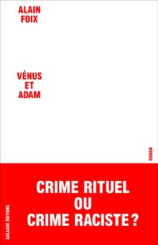
FRONTLIST / FALL 2010
WORLD RIGHTS / NON FICTION / "AUTEUR DE VUE" SERIES

A personal survey of one country's
memories and traumas

AVIRAMA GOLAN
THE WOUNDED GRAPEVINE TENDRIL
(WORKING TITLE)

ESSAY  A letter from an Israelian woman to an Arab woman friend, The Wounded Grapevine Tendril tells the story of the foundations of a friendship, in light of the fears and mutual suspicion embedded in them.  Alternating the point of view of Avirama Golan and the one of a friend whom Avirama Golan interviewed in the late 1980s, this essay constitutes a historical-sociological survey of the situation of the Arabs in Israel.  It is also a discussion on the present, on the fear that the fragile balance between the two populations in Israel will collapse beneath the hatred and the fear, and the wounded grapevine tendril, which needs to heal, to be tied to a trellis and receive nurturing in order to blossom, will break and die.  - upmarket  - when women speak about the conflict  - from the personal to the geopolitical  RIGHTS AVAILABLE  Agent: The Institute for the Translation of Hebrew Literature  Reading copy soon available  96 P. TO BE PUBLISHED IN 2011 |   The author  Avirama Golan has worked for Ha'aretz for the past 20 years. Since 1999, she also has her own weekly TV show, "First Reading”, where she interviews writers and readers of new books. Her previous books were translated into numerous languages including Italian and German.
FRONTLIST / FALL 2010
WORLD RIGHTS / NON FICTION / "AUTEUR DE VUE" SERIES

How to renovate the press today

EDWY PLENEL
COMBAT POUR UNE PRESSE LIBRE
(TO FREE THE PRESS)

ESSAY

In this incisive and thought-provoking manifesto, one of France’s leading journalist and founder of the independent and “participative” digital newspaper Mediapart, addresses the three crises –democratic, economic and moral– that undermine information today in France. Against recent measures that contribute to reinforce media subordination to state authority, Combat pour une presse libre defends independence and calls for a deeply reorganized and rethought press.  “Imagine a country endowed with a founding act on the freedom of information, an act that forces public figures to answer citizens curiosity, journalists questions, medias investigations, and demanding every administrative document necessary for the public information to be unveiled. Imagine a president and a majority who, far from being frightened by such political liberalities, decide to increase it, proclaiming the ‘priority to transparency’.” – Edwy Plenel  "Reflection and commitment" – le nouvel économiste  "Combat alerts the public opinion on the dangers that weigh on a free and independent press." – les inrockuptibles  Al-Jazeera’s “Empire” guest on the week of the book’s release: Edwy Plenel, a major commentator of today’s France.  - medias / politics / democracy  - An incisive address to the three crises of the press  RIGHTS AVAILABLE  96 P. MAY 2009 | 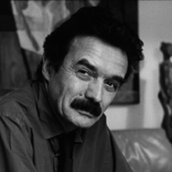  The author  Edwy Plenel is the author of La République inachevée (Stock, 1997), La Part d’ombre (Gallimard, 1994), Secrets de jeunesse (Stock, 2001), La Découverte du monde (Stock, 2002) and Procès (Stock, 2006). Former editor in chief for Le Monde during the past twenty-five years, professor at Montpellier University, Edwy Plenel founded Mediapart in 2007.

